day 2 task

DOCUMENT

document is inside the property of windows object

document is the HTML VIEW PORT, the example of HTML BODY of the element was a document property

Document object was get inside HTML files

its use for a frame work properties

WINDOW

window was a parent property element of the browser .

All property file get in windows object , that was all application and chrome is one of example of the window object.

windows object was lot of property inside the windows object .

WINDOW object is only available at browser, but not visible in node js .

window vs document in one line answer was,

window is was a container (all property is here)

document is was a one of the inside property of window ( HTML FILE IS HERE)

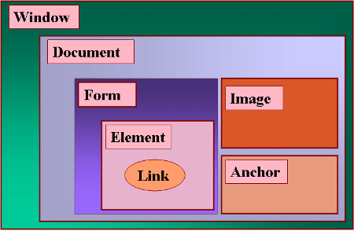

In the picture above visible green color was a window

And then document is available in inside of the window

`WINDOW is browser object ` DOCUMENT is one of the property in WINDOW.

**DOM – DOCUMENT OBJECT MODEL**

Submitted by

Mohan suntharam .r **(B53)**

[romanrishi8@gmail.com](mailto:romanrishi8@gmail.com)